**//FAISAL RASOOL QAZI**

**//455689**

**//ME - 15 SEC-B**

**//LAB MANUALS-6**

**//TASK 01**

#include <iostream>

using namespace std;

int main ()

{

int terms, first=0, second=1,next;

cout<<"Enter the number of terms you want in the sequence: ";

cin>>terms;

cout<<"The sequence is: "<<endl;

for (int i=1; i<terms; i++)

{

for (int j=1; j<=i; j++)

{

cout<<first<<endl;

next=first+second;

first=second;

second=next;

}

}

return 0;

}

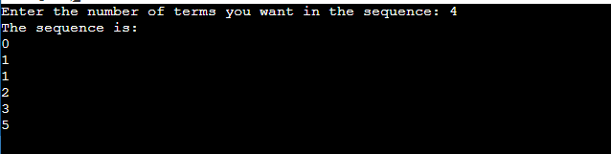

**//TASK 02**

#include <iostream>

using namespace std;

int main ()

{

int size, number=1;

cout<<"Enter the no. of rows for floyd's triangle :";

cin >> size;

for (int i = 0; i<=size; ++i){

for (int j=0; j<=i; ++j) {

cout << number << " ";

++number;

}

cout<<endl;

}

return 0;

}

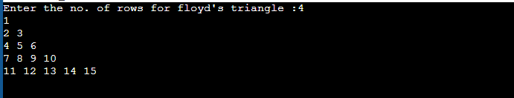

**//FAISAL RASOOL QAZI**

**//455689**

**//ME-15 SEC-B**

**//FOP 06 HOME TASKS**

**//TASK 01**

#include <iostream>

using namespace std;

int main() {

int num, i, sum ;

for(num=2; num<=50; num++) {

for(i=2; i<=(num/2); i++) {

if(num%i==0) {

i=num;

break;

}

}

if(i!=num) {

sum = sum+ num;

}

}

cout<<"Sum of all prime numbers upto 50 is :" << sum;

return 0;

}

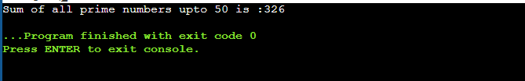

**//TASK 02**

#include <iostream>

using namespace std;

int main()

{

int rows =5;

for (int i=1; i<=rows; i++)

{

for (int j=1; j<=i; j++)

{

cout<<j<< " ";

}

cout<<endl;

}

return 0;

}

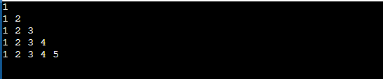

**//TASK 03**

#include <iostream>

using namespace std;

int main (){

int z=2;

cout<<"1"<<"\n";

for(int i=2 ; i<=5 ; i++){

for(int j=1 ; j<=i ; j++){

cout<<z<<"\t";

}

z=z+2;

cout<<"\n";

}

}

